Viral Joshi

Github repo: <https://github.com/viralj>

Docker repo: <https://hub.docker.com/u/viraljoshi23/>

You can find detailed instructions of how to run the project in Github instructions.

Following are screen shots of requirements

Travis CI successful build

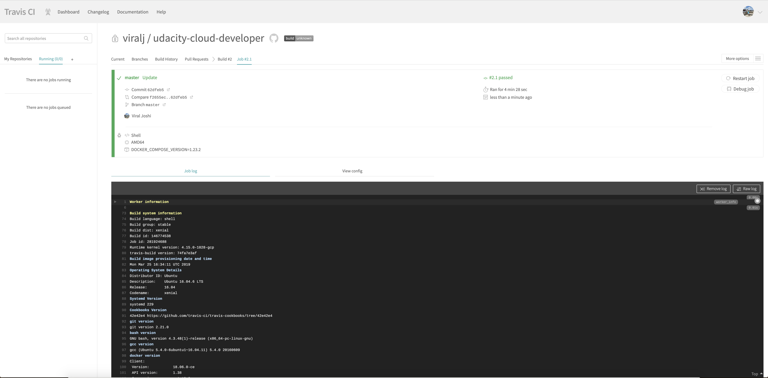

Kkubernetes pods that are running initially

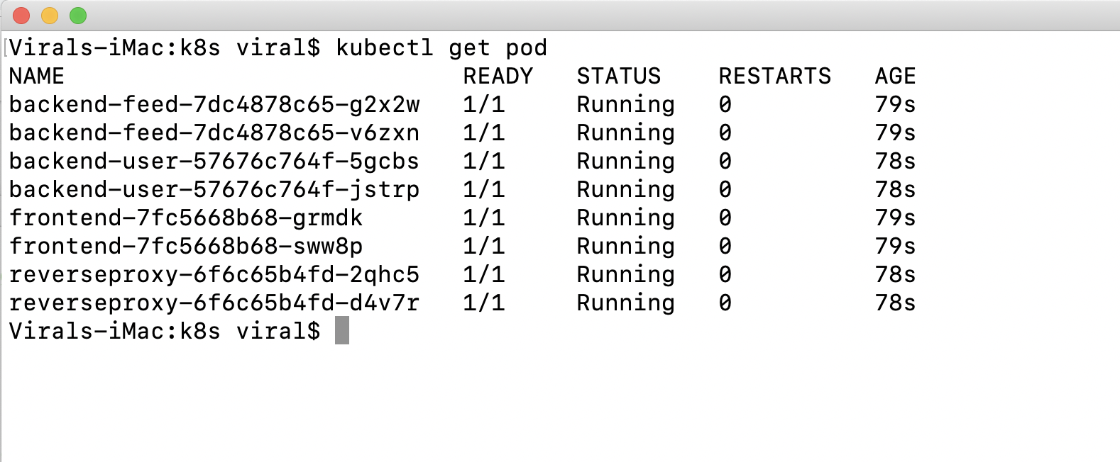

Project running after deployment



Kubernetes new pod backend-feed-b deployment and running containers

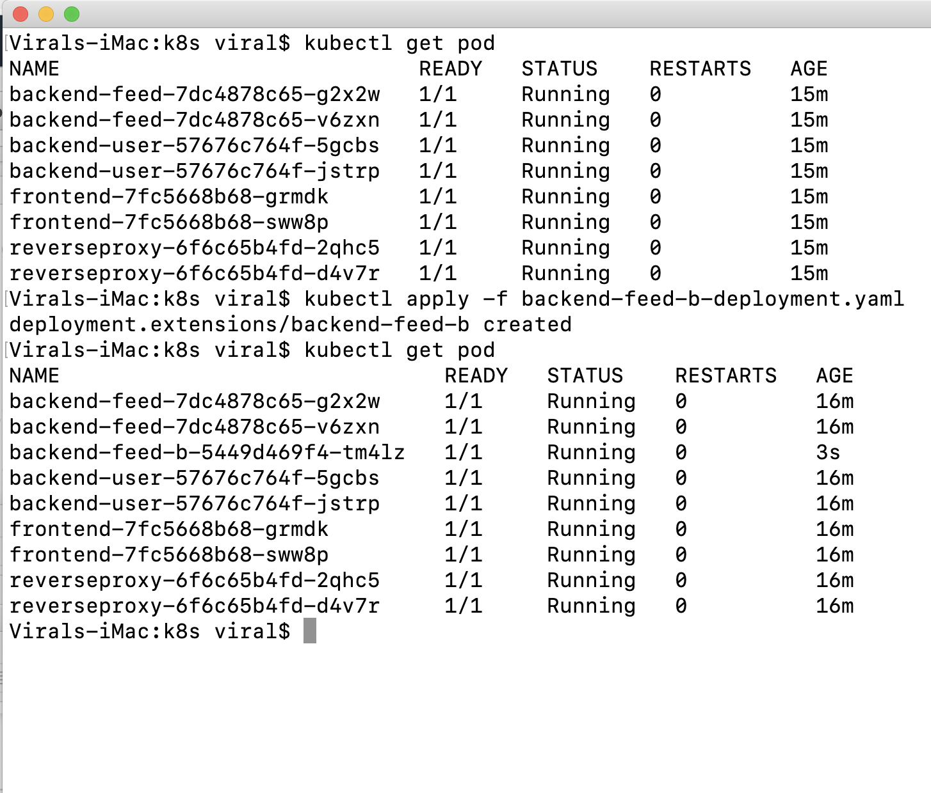

Project running after deployment of new pod

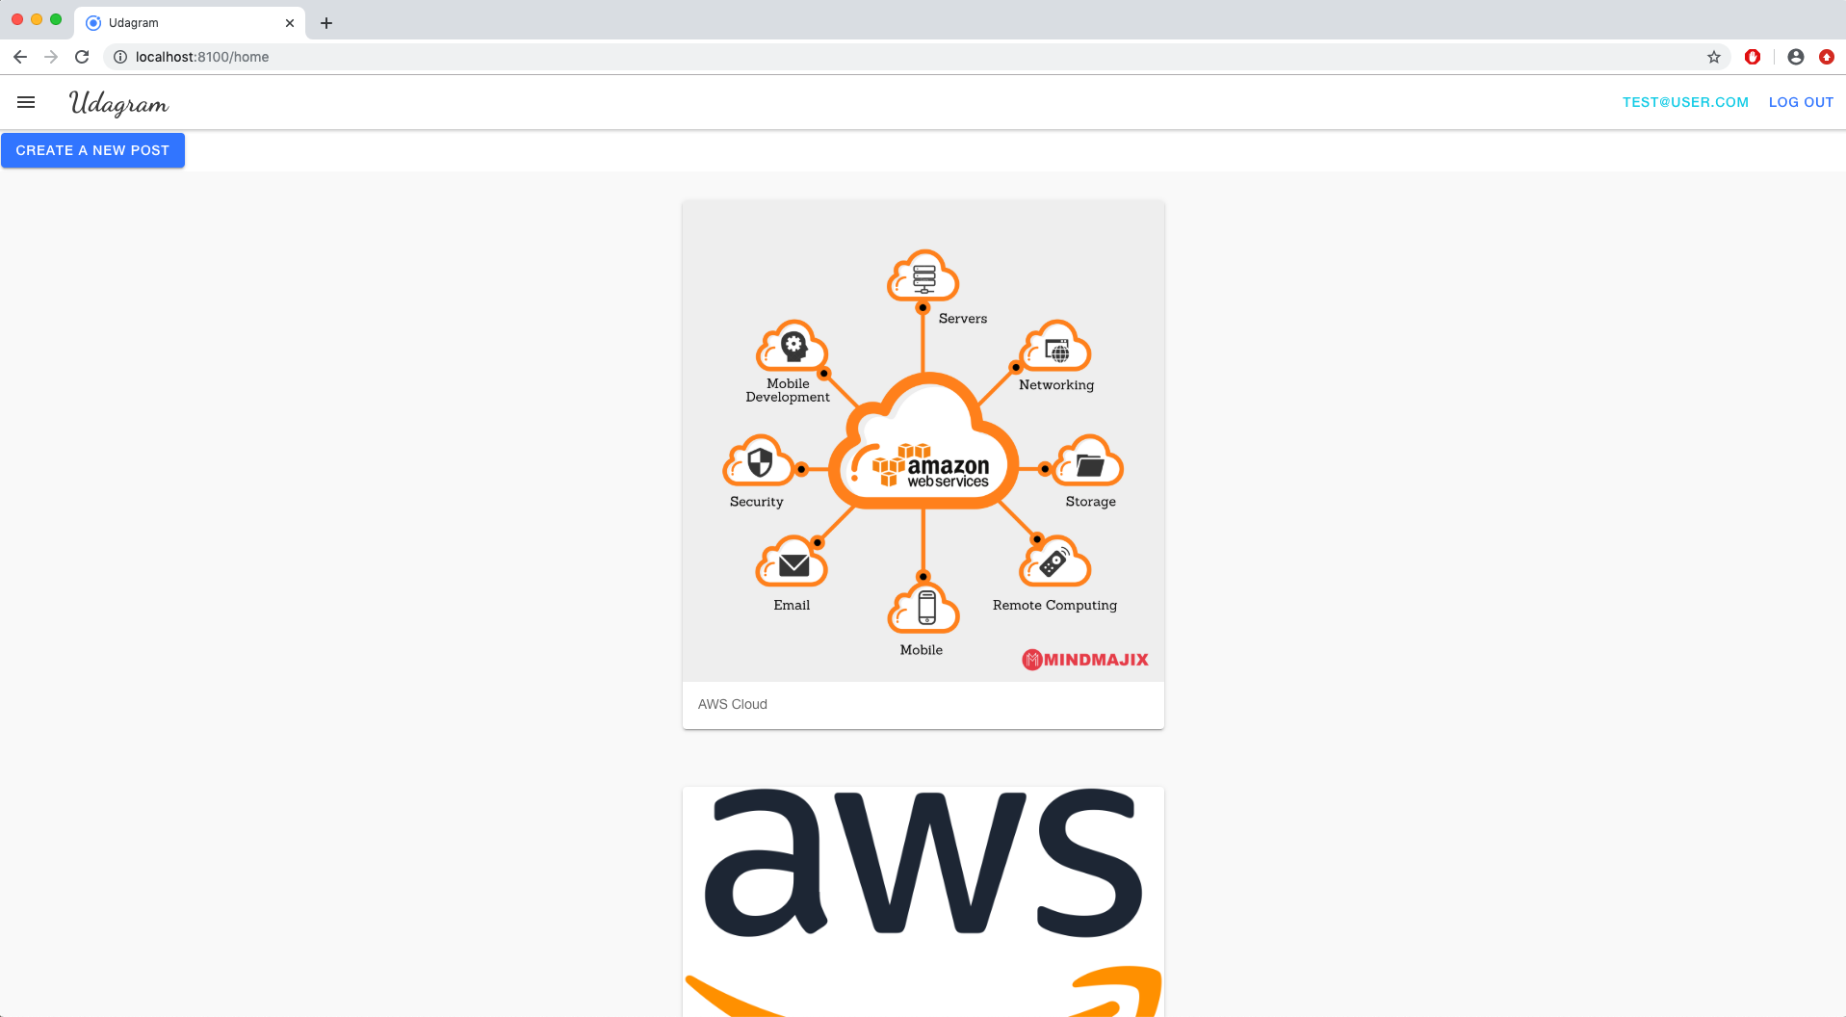

AWS CloudWatch metrics for all three EC2 instances

